15BT101-BIOLOGY FOR ENGINEERS

UNIT I
Question No 1:
Explain Five kingdom classification with examples: (4 Marks)*
FIVE KINGDOM CLASSIFICATION:.
- The five kingdoms are Monera, Protista, Fungi, Plantae, and Animalia. The Monera consists of unicellular organisms that lack a nucleus and many of the specialized cell parts, called organelles.
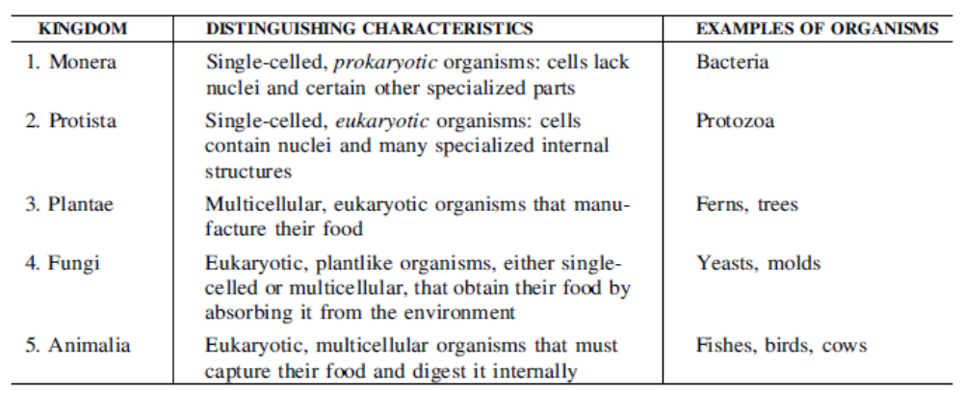

Question No 2: (4 Marks)*
Write down the postulates of CELL THEORY
The cell Theory was proposed by Theodore Schwann and Matthias Schleiden
- The cell is the basic structural and functional unit of life .
- All living things are made up of cells.
- All are arise from preexisting cells.

Question No 3: (4 Marks or 6 marks)
What are Prokaryotes ? Explain
- A prokaryote is a unicellular organism that lacks a membrane-bound nucleus, mitochondria, or any other membrane-bound organelle.
- In the prokaryotes, all the intracellular water-soluble components(proteins, DNA and metabolites) are located together in the cytoplasm enclosed by the cell membrane, rather than in separate cellular compartments.

Prokaryotic cell structure
Flagellum (only in some types of prokaryotes)
Long, whip-like protrusion that aids cellular locomotion used by both gram positive and gram negative organisms.
Cell membrane
Surrounds the cell's cytoplasm and regulates the flow of substances in and out of the cell.
Cell wall (except genera Mycoplasma and Thermoplasma)
Outer covering of most cells that protects the bacterial cell and gives it shape.
Cytoplasm
A gel-like substance composed mainly of water that also contains enzymes, salts, cell components, and various organic molecules.
Ribosome
Cell structures responsible for protein production.
Nucleoid
Area of the cytoplasm that contains the prokaryote's single DNA molecule.
Glycocalyx (only in some types of prokaryotes)
A glycoprotein\-polysaccharide covering that surrounds the cell membranes.
Inclusions
It contains the inclusion bodies like ribosomes and larger masses scattered in the cytoplasmic matrix

Reproduction:

Prokaryotes reproduce through asexual reproduction, usually by binary fission.

Prokaryotes

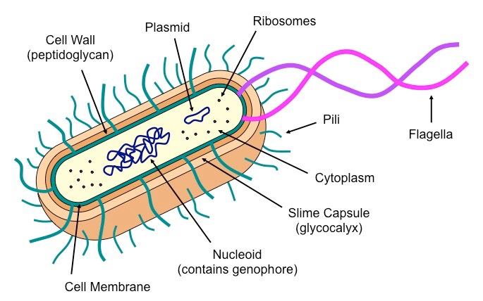

Question No 4: Write a note on Cellular Metabolism or Describe ATP
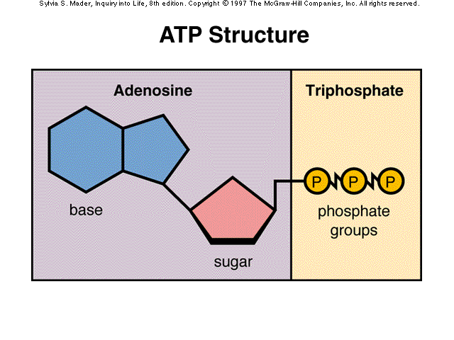
- ATP is consumed in the cell by energy-requiring (endothermic) processes and can be generated by energy-releasing (exothermic) processes. In this way ATP transfers energy between spatially-separate metabolic reactions.
- ATP is the main energy source for the majority of cellular functions.
- Chemical function : The synthesis of macromolecules, including DNA and RNA, and proteins.
- Transport function: ATP plays a critical role in the transport of macromolecules across cell membranes, e.g. exocytosis and endocytosis.
- Mechanial Function : ATP is critically involved in maintaining cell structure by facilitating assembly and disassembly of elements of the cytoskeleton.

Question No 5: (4 Marks)*
Describe the difference between Anabolism and Catabolism

S.No | ANABOLISM | CATABOLISM
1. | Anabolism is also known as ‘biosynthesis’, whereby an end product is created from a number of components. | Catabolic processes are destructive, where more complex compounds are broken down
2. | The process requires ATP as a form of energy. They are Aerobic reactions. | Energy is released in the form of ATP or heat instead of consuming energy as in anabolism. They are generally anaerobic reaction.
3. | Water molecules are removed in this process (Dehydration). | Water molecule is added in this process (Hydration).
4. | Example: amino acids becoming polypeptides (proteins), glucose becoming glycogen, fatty acids becoming triglycerides, Cell respiration, Digestion, Excretion | Example : Proteins becoming amino acids, proteins becoming glucose, glycogen becoming glucose, or triglycerides becoming fatty acids. Assimilation in animals, Photosynthesis in plants

Question No 6: (4 Marks)*
Define Homeostasis with example
Definition: Homeostasis refers to the ability of the body or a cell to seek and maintain a condition of equilibrium or stability within its internal environment when dealing with external changes.
Components : 1) sensor
2) afferent pathway
3) integration center or comparator
4) efferent pathway
5) effector organ(s)

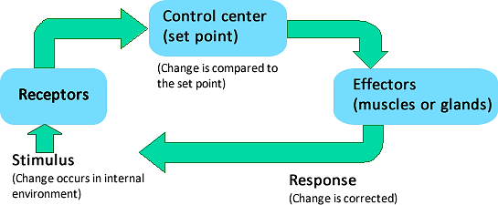
Physiological control systems are the nervous system, endocrine system, and immune system through feedback mechanisms.
- Example: Controlling body temperature - All mammals maintain a constant body temperature. Human beings have a body temperature of about 37ºC. The body temperature is maintained based on the external temperature by the process of Vasoconstriction or Vasodilation.
Question No 7: (4 Marks)*
Write about positive and negative feedback mechanism
- Positive feed back mechanism are designed to accelerate or enhance the output created by a stimulus that has already been activated.
- Example : Blood platelet accumulation which in turn causes the blood clotting response to a break or tear in blood vessel.
- Negative feed back mechanism consist of reducing the output pr activity of any organ or system back to its normal range of fumction
- Example : Regulation of body temperature, glucose level, blood pressure

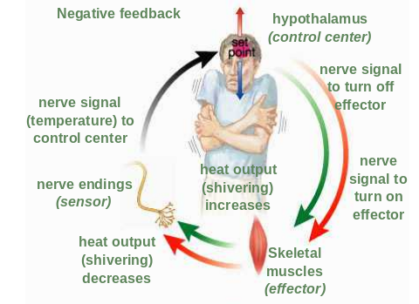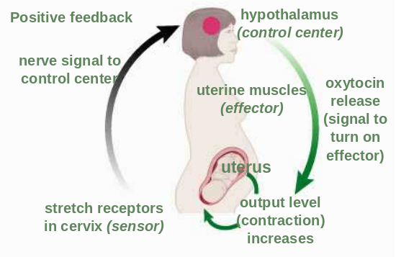

Question No. 8
Difference between mitosis and meiosis
S.No | Mitosis | Meiosis
1. | It occurs in somatic cells | I t occurs in germ cels
2. | Two identical daughter cells are formed | Four non identical daughter cells are formed
3. | The cells are diploid cells | The cells are haploid cells
4. | It is a continuous process | It is a dis continuous process
5. | It occurs in sexual and asexually reproducing organism | It occurs only in sexually reproducing organism

Question No. 9
Difference between plant cell and Animal cell

S.No | Plant cell | Animal Cell
1. | - Plant cells have a cell wall . Cell walls a rigid structures made of cellulose (basically wood). | - Animal cells do not have a cell wall
2. | - Plant Cells have one or two LARGE vacuoles. These vacuoles many hold water for the cells | - Animal cell vacuoles are numerous, small, and contain water, food, and waste.
3. | - Plant cells do not have mitochondria | - Animal cells use mitochondria to release energy
4. | - They also do not have lysosome. | - Animal cells have lysosomes
5. | - Plant cells have chloroplast  - Plant cells use chloroplast to store energy  - Cytokinesis occurs by cell plate formation | - Do not go through photosynthesis .they are heterotrops  - Cytokinesis occurs by formation of furrow between the cells of telophase

Question No.10:
Explain the type of reproduction in bacterial cell/prokaryotic cell/binary fission
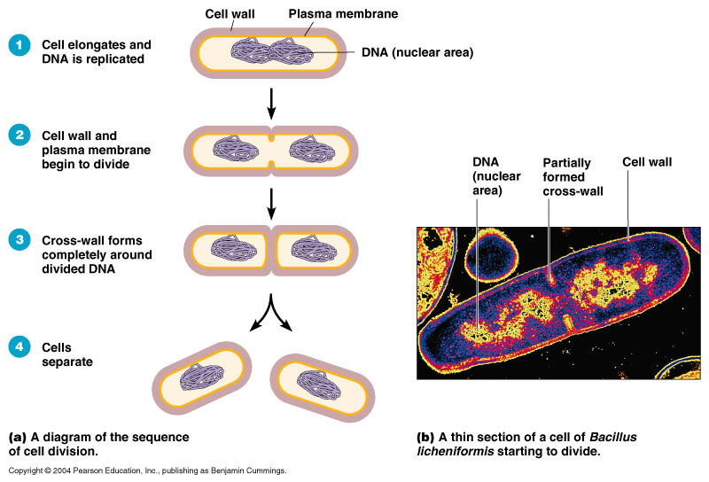
Bacteria are prokaryotic organisms that reproduce asexually. Bacterial reproduction most commonly occurs by a kind of cell division called binary fission. Binary fission results in the formation of two bacterial cells that are genetically identical

